Q1.

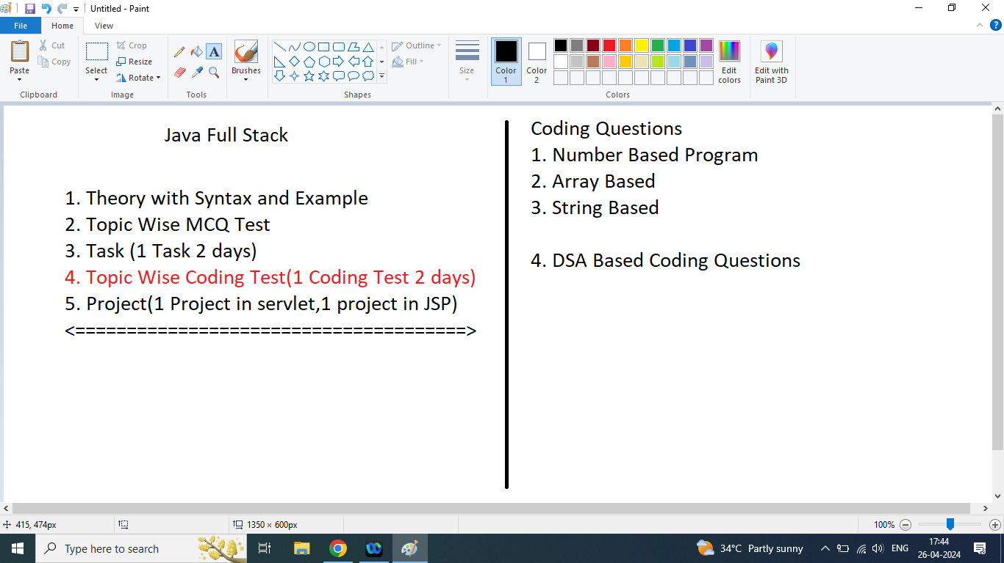

Subjects:

1. Core Java(2 Months)
2. Advanced Java(2 Months)

* SQL(Mysql)
* JDBC
* DSA
* Servlet
* JSP

1. Framework(2 Month)
2. Spring Framework
3. Spring MVC
4. Hibernate
5. Spring Boot
6. REST API Using Spring Boot

(1 Project)

Core Java

1. Basics of Java Programming
2. Software Requirement(JDK 1.8,mysql 8.0, IDE(Netbeans 8.2, Eclipse, STS 4.0 ) )
3. How to set path
4. Java Program structure
5. Java Sample Program say Hello world
6. Java Output methods
7. Data types and variables
8. How to take input from the user(Scanner)

MCQ Test

Input output based task

Operators

1. Arithmetic Operators[+,-,\*,/,%,++,--]
2. Relational Operators [>,<,>=,<=,==,!=]
3. Logical Operators [&&,||,!]
4. Bitwise Operators[&,|,~,<<,>>,^]
5. Ternary Operator [? :]
6. Assignment Operators[=,+=,-=,\*=,/=,%=]
7. Precedence of an Operators
8. Associativity of an Operators

MCQ Test

Control Flow Statement

1. Conditional Statement
2. if
3. if else
4. else if
5. nested if
6. switch
7. Looping Statement
8. while
9. do while
10. For
11. For each
12. Jumping Statement
13. break
14. continue

Logical Program

MCQ Test

Number Based Task (75 Questions)

Coding Test

Array

1D Array

2D Array

Array Based Task

MCQ Test

Coding Test

String(Immutable)

StringBuffer(Mutable)

StringBuilder(Mutable)

Methods

Constructor

Coding Test

String Based Task

MCQ Test

OOPS Concepts

1. Class
2. Object
3. Member data
4. Member functions
5. Access Specifier(private,public,protected)
6. Constructor
7. Encapsulations
8. Inheritance
9. Polymorphism
10. Compile time(Method overloading)
11. Run Time(Method Overriding)
12. Abstractions
13. static(block,variable,method)
14. final(variable,method,class)
15. Interface
16. Multiple inheritance through interface

Exception Handling

try

catch

throw

throws

Finally

Types of Exception

1. Checked Exception(Mandatory to handle it)
2. Unchecked Exception(Optional to handle it)

Types of Exception

1. Pre-Defined Exception
2. User Defined Exception